November 2, 2016

Dear MPact Coordinators:

Greetings in the precious name of our Lord! I can hardly believe that the holidays are just around the corner. We have made great memories in 2016 through MPact Leadership Development days, the MPact Retreat, and at local Honor Star Celebrations. Our attendance at the Brave MPact Retreat in July was the highest it has been in ten years. I will always cherish the times spent with girls earnestly seeking God around the altar during our chapel services. Your love for God, love for the next generation, and ongoing commitment to discipling and mentoring girls are an inspiration.

This packet contains valuable information for Girls’ Ministry in 2017. Your hearts will be incredibly moved by Natali Williams and her Jigiya So project in Mali. This critical project ministers to “the least of these” – the Garibou boys who are on the streets of the capital city of Mali. Due to safety issues and sensitive nature of ministry in a Muslim culture, we cannot post the ministry video on our website or social media. Therefore, we have enclosed a hard copy DVD from Natali. Please take the time to view it and share it with your Mpact girls and sponsors. You don’t want to miss out on this incredible opportunity! We are also including a 2016 color, tri-fold TTW brochure and information on downloadable TTW resources.

Enclosed in this mailing is the 2017 Chartering Application. If you desire to charter, please return this form with your annual fee to the District Office by January 17, 2017. We are continually adding names to our email database for e-newsletters. Yet, email addresses often change. When completing your report, please make sure that we have your correct email and the correct emails for your sponsors. All sponsors chartering by the deadline will be entered into a drawing for a $25 gift card for arts & craft supplies.

Another enclosure is the 2017 Missionary Adoption form. I urge your MPact ministry to adopt a missionary family in 2017. It is a wonderful way to provide encouragement and be part of what God is doing around the world. This connection additionally helps model missionary giving and prayer for missionaries to our girls.

Thank you for your monthly tithes and contributions to the North Carolina Girls’ Ministries Department. Please know that your faithful financial support is ever appreciated and never taken for granted. Your faithfulness enables us to pursue excellence in ministry to the girls of North Carolina.

Beloved leaders of girls, my prayer over us is Colossians 1:10 that we will: “live a life worthy of the Lord and please him in every way: bearing fruit in every good work, growing in the knowledge of God,” May His love fill our hearts, His spirit lead us, and may we bear good fruit throughout 2017.

Many blessings,
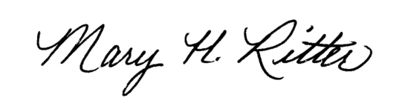
Mary Ritter
NC District Girls’ Ministries Coordinator

