November 8, 2017

Dear MPact Coordinators:

Greetings in the precious name of our Lord! I can hardly believe that the holidays are just around the corner. We have made great memories in 2017 through MPact Leadership Development days, the MPact Retreat, and at local Honor Star Celebrations. Our attendance at the Chosen MPact Retreat in July was outstanding. I will always cherish the times spent with girls earnestly seeking God around the altar during our chapel services. Your love for God, love for the next generation, and ongoing commitment to discipling and mentoring girls are an inspiration.

This packet contains valuable information for Girls’ Ministry in 2018. We are excited about our partnership with Convoy of Hope Women’s Empowerment. This initiative ministers to women through Mother’s Clubs, Empowered Girls, and Micro+ which provides seed capital for small business. We are targeting El Salvador with our giving. There are several powerful videos on our website showing how these investments are changing the lives of women and their families. Please take the time to view them and share them with your MPact girls and sponsors. We are also planning a missions trip to El Salvador with Convoy Women in March. Additional information and applications are available on our website. You don’t want to miss joining this incredible partnership! We are also including a 2018 color, tri-fold TTW flyer, some Convoy Women’s brochures, and information on downloadable TTW resources.

Enclosed in this mailing is the 2018 Chartering Application. If you desire to charter, please return this form with your annual fee to the District Office by January 16, 2018. We are continually adding names to our email database for e-newsletters. Yet, email addresses often change. When completing your report, please make sure that we have your correct email and the correct emails for your sponsors. All sponsors chartering by the deadline will be entered into a drawing for a $25 gift card for arts & craft supplies.

Another enclosure is the 2018 Missionary Adoption form. I urge your MPact ministry to adopt a missionary family in 2018. It is a wonderful way to provide encouragement and be part of what God is doing around the world. This connection additionally helps model missionary giving and prayer for missionaries to our girls.

Thank you for your monthly tithes and contributions to the North Carolina Girls’ Ministries Department. Please know that your faithful financial support is ever appreciated and never taken for granted. Your faithfulness enables us to pursue excellence in ministry to the girls of North Carolina.

Beloved leaders of girls, my prayer over us is Colossians 1:23 that we will: “continue in the faith, grounded and steadfast, and are not moved away from the hope of the gospel….” May our faith and hope in Him be strengthened, and may we demonstrate this faith and hope through His love to our world in 2018!

Many blessings,
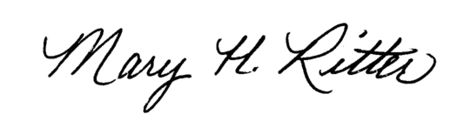
Mary Ritter
NCAG Girls’ Ministries Coordinator

